

**Project of Business Intelligence**

**Data Analytics Internship**

**HR Analysis Dashboard Report**



*Done by :* Aziz Hafsa

Year : 2023-2024

# **Introduction :**

Understanding employee career informations is crucial for organizations aiming to enhance productivity and retain talent. This report provides a comprehensive analysis of the HR Analysis Dashboard created using Power BI, exploring key metrics and offering actionable insights to support decision-making processes. Career development opportunities significantly impact employee performance and organizational outcomes. This report aims to investigate the factors influencing attrition,job involvemeny , job satisfaction , work-life balance and career development to provide data-driven recommendations for enhancing employee engagement and advancement.

Table des matières

**I.** **Introduction :** 2

**II.** **Data Import and Exploration :** 5

**1.** **Loading Data into Power BI :** 5

**2.** **Initial Data Cleaning and Preparation :** 5

**III.** **Descriptive Analytics :** 6

**IV.** **Visualisation :** 7

**V.** **Interpretation :** 9

**1.** **Filters :** 9

**2.** **Main Metrics :** 10

**A.** **First Page :** 11

**1.** **Attrition by Age :** 11

**2.** **Attrition by Years Since Last Promotion :** 11

**3.** **Attrition by Job Role :** 11

**4.** **Attrition by Department and Gender :** 11

**5.** **Job Satisfaction, Years at Company, and Monthly Income :** 11

**6.** **Distance from Home :** 11

**B.** **Seconde Page :** 12

**1.** **Average Involvement by Department:** 12

**2.** **Average Involvement by Job Role:** 12

**3.** **Average Balance by Department:** 12

**4.** **Average Satisfaction by Department:** 12

**5.** **Average Involvement by Education Field:** 13

**6.** **Average Satisfaction by Business Travel:** 13

**7.** **Percentage of Overtime by Job Role :** 13

**8.** **Count of gender and Involvement by Marital Status:** 13

**9.** **Comparison of Percentage Overtime, Average Satisfaction, and Average Balance by Department :** 14

**C.** **Third Page :** 15

**1.** **Percentage of Overtime by Business Travel:** 15

**2.** **Distribution of Overtime:** 15

**3.** **Count of Overtime by Gender:** 15

**4.** **Percentage of overtime by Department  :** 15

**D.** **Forth Page :** 16

**1.** **Average Years in Current Role and Satisfaction by Department:** 16

**2.** **Average Years Since Last Promotion and Job Level by Education Level:** 16

**3.** **Average Years Since Last Promotion by Job Role:** 16

**4.** **Average Years Since Last Promotion by Department:** 17

**5.** **Average Years Since Last Promotion by Gender:** 17

**6.** **Average Years Since Last Promotion by Overtime:** 18

**7.** **Average Involvement and Years Since Last Promotion by Department:** 18

**8.** **Sum of Employee Count by Education Level:** 18

**VI.** **Recommendations :** 19

**VII.** **Conclusion :** 20

# **Data Import and Exploration :**

### **Loading Data into Power BI :**

The dataset was loaded into Power BI using the Power Query Editor, ensuring data types were verified and corrected.

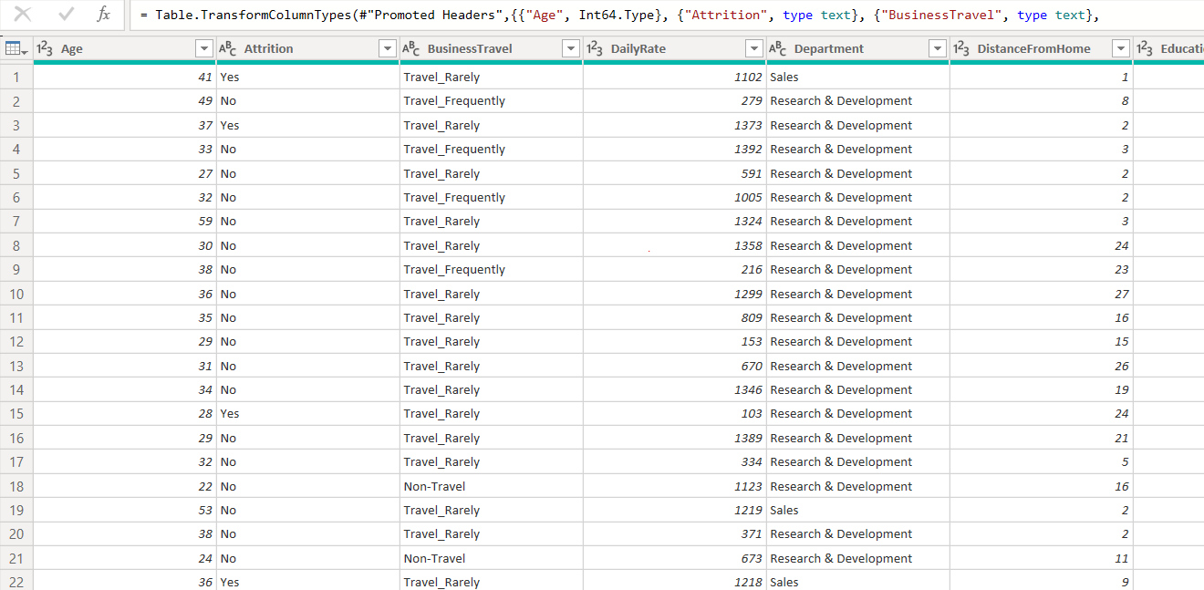

### **Initial Data Cleaning and Preparation :**

Once the data was collected, we prepared it by performing cleaning and transformation steps. This included handling missing values, converting data to the appropriate format, eliminating outliers or inconsistent values, and any other necessary steps to ensure data quality.

# **Descriptive Analytics :**

The dataset typically includes various features that provide insights into employee characteristics, job satisfaction, and performance. Here's a list of common features found in the dataset:

1. **Employee ID:** A unique identifier for each employee.
2. **Age:** The age of the employee.
3. **Gender:** The gender of the employee.
4. **Job Role:** The specific role or title of the employee's job.
5. **Department:** The department to which the employee belongs.
6. **Marital Status:** The marital status of the employee.
7. **Business Travel:** The frequency and nature of business-related travel.
8. **Job Involvement:** The degree to which the employee is involved in their job.
9. **Job Satisfaction:** The level of satisfaction with the job.

10.**Work-Life Balance:** The balance between work and personal life.

11.**Over Time:** Whether the employee works overtime or not.

# **Visualisation :**

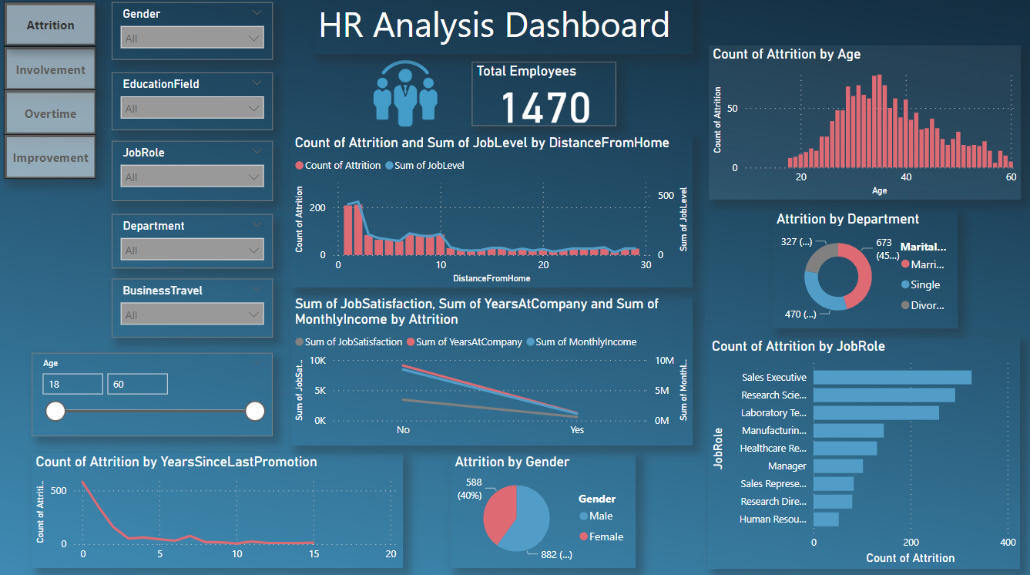

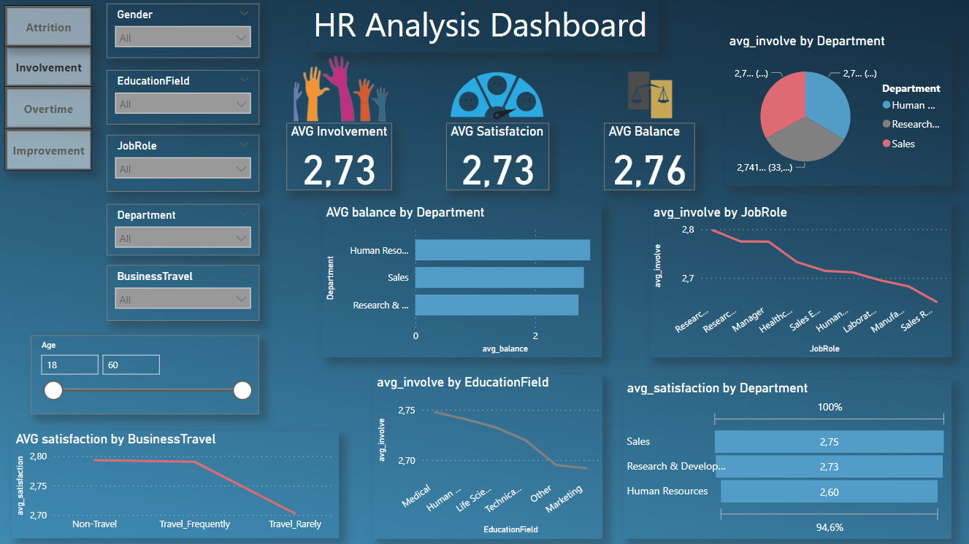

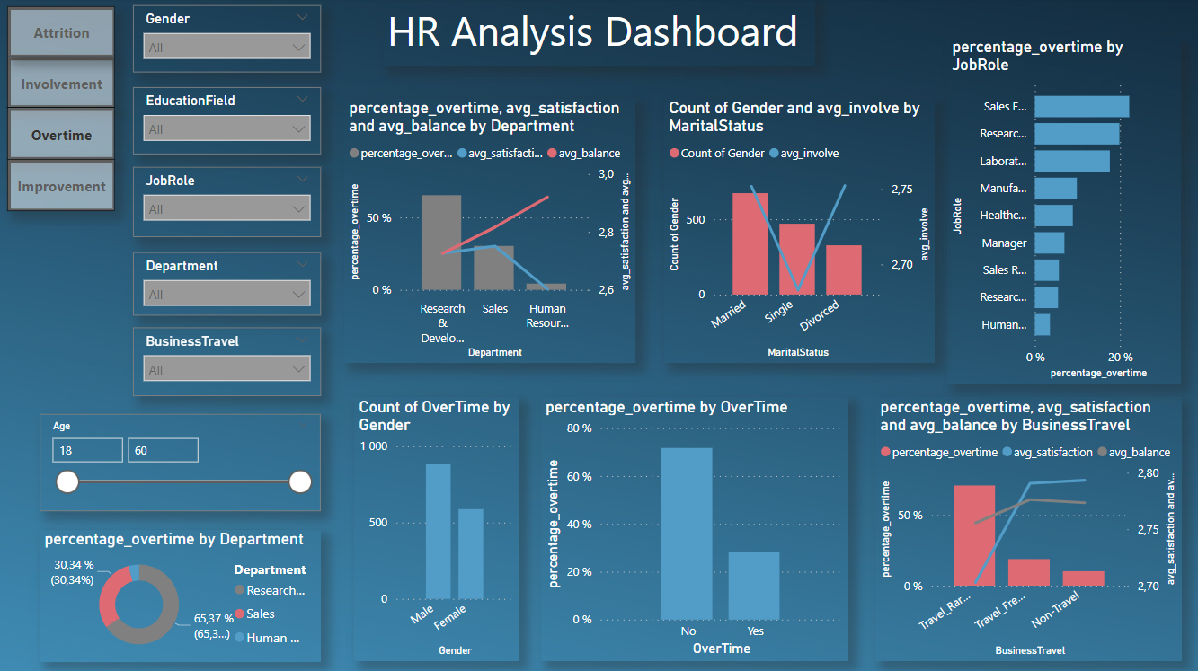

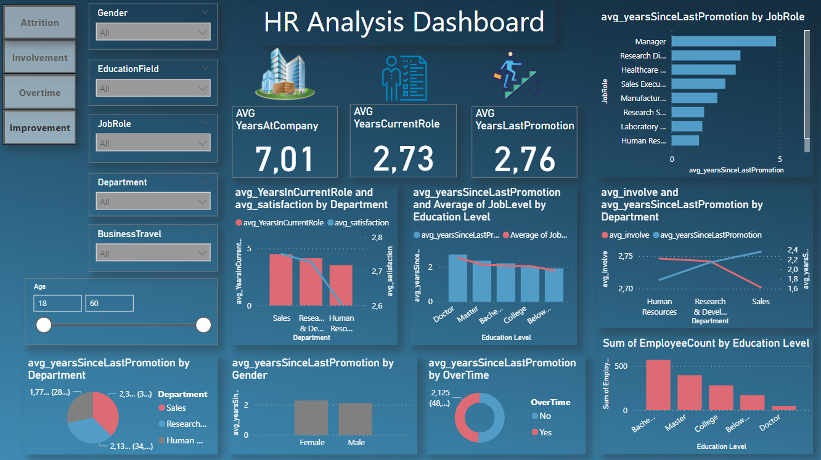

The Attrition page that includes metrics such as overall turnover rate, job satisfaction, performance ratings, and provides insights into attrition by department, gender, age, job role, and other critical dimensions. Through descriptive and predictive analytics, this page aids in developing data-driven strategies to improve employee retention.Besides The Involvement page that provides a comprehensive analysis of various aspects related to job involvement, satisfaction, and balance. It includes metrics and visualizations such as average involvement, satisfaction, balance, and detailed breakdowns by gender, department, job role, marital status. Then the Overtime page that is designed to provide a comprehensive analysis of its influence on the employees satisfaction and balance within an organization. Also The Improvement page that provides a comprehensive analysis of various aspects related to career development, job roles, and departmental trends. It includes metrics and visualizations such as average years at the company, years in the current role, and years since the last promotion.

# **Interpretation :**

## **Filters :**

**Gender:** The dashboard allows filtering by gender (Female, Male) to analyze differences in job involvement, satisfaction, and balance between genders.

**Education Field:** Users can filter the data by various education fields such as Life Sciences, Medical, Marketing, etc., to understand how educational background influences job involvement.

**Job Role:** Filtering by job roles such as Sales Executive, Research Scientist, Manager, etc., helps in identifying job involvement trends specific to each role.

**Department:** The dashboard provides a filter for departments like Sales, Research & Development, and Human Resources to analyze department-specific job involvement metrics.

**Business Travel :** The dashboard provides a filter for **Business Travel like Non-Travel , Travel-Frequently or Travel-Rarely.**

**Age:** An age slider filter (18-60) is available to explore how job involvement varies across different age groups.

## **Main Metrics :**

**Toltal Employees :** The count of all employees in the company.

**Average Involvement :** the dashboard, showing overall average scores for job involvement (2.73)

**Average Satisfaction :** the dashboard, showing overall average scores for job satisfaction (2.73)

**Average Balance:** the dashboard, showing overall average scores forwork-life balance (2.76).

**Average Years at Company:** Displayed as 7.01 years. This indicates a relatively stable workforce with moderate employee retention.

**Average Years in Current Role:** Displayed as 2.73 years. This suggests a need for regular career development opportunities to keep employees engaged.

**Average Years Since Last Promotion:** Displayed as 2.76 years. This indicates potential stagnation and highlights the importance of reviewing promotion policies.

## **First Page :**

### **Attrition by Age :**

The count of attrition is higher in the age group of 30-40 years, indicating mid-career employees are more likely to leave.

### **Attrition by Years Since Last Promotion :**

A significant drop in attrition is observed for employees who were promoted within the last 0-5 years, emphasizing the importance of career advancement opportunities.

### **Attrition by Job Role :**

Sales Executives and Research Scientists show higher counts of attrition, suggesting these roles might have specific challenges contributing to higher turnover.

### **Attrition by Department and Gender :**

The Sales department has the highest attrition rate, followed by Research & Development. Males have a higher count of attrition compared to females.

### **Job Satisfaction, Years at Company, and Monthly Income :**

Employees who are leaving tend to have lower job satisfaction and lower monthly income, suggesting these are critical factors in retention strategies.

### **Distance from Home :**

Attrition is higher for employees living closer to the workplace, possibly indicating issues unrelated to commute distance, such as job satisfaction or work environment.

## **Seconde Page :**

### **Average Involvement by Department:**

**Visualization:** A pie chart showing average job involvement scores by department.

**Insights:** Research & Development has the highest job involvement score, followed by Sales and Human Resources.

### **Average Involvement by Job Role:**

**Visualization:** A line chart showing average job involvement by job role.

**Insights:** Job involvement varies significantly across different roles, with Research Scientists showing the highest involvement and Sales Representatives the lowest.

### **Average Balance by Department:**

**Visualization:** A bar chart showing the average balance score by department.

**Insights:** Human Resources and Sales departments have lower average balance scores compared to Research & Development, indicating potential work-life balance issues.

### **Average Satisfaction by Department:**

**Visualization:** A bar chart showing average job satisfaction scores by department.

**Insights:** Sales and Human Resources have lower job satisfaction scores compared to Research & Development, indicating areas needing improvement in job satisfaction.

### **Average Involvement by Education Field:**

**Visualization:** A line chart showing average job involvement by education field.

**Insights:** Employees with a background in Medical and Life Sciences show higher job involvement compared to those in Marketing or Technical fields.

### **Average Satisfaction by Business Travel:**

**Visualization:** A line chart showing average job satisfaction by the frequency of business travel.

**Insights:** Employees who travel rarely or not at all report better job satisfaction compared to those who travel frequently.

### **Percentage of Overtime by Job Role :**

**Visualization:** A horizontal bar chart showing the percentage of overtime by job roles.

**Insights:** Roles such as Sales Executives and Research Scientists have higher percentages of overtime, indicating job roles with significant workload or time demands.

### **Count of gender and Involvement by Marital Status:**

**Visualization:** A dual-axis chart displaying the count of gender and average job involvement across different marital statuses.

**Insights:** Married employees show higher job involvement compared to single and divorced employees. The count of male and female employees varies across marital statuses, impacting job involvement metrics.

### **Comparison of Percentage Overtime, Average Satisfaction, and Average Balance by Department :**

**Visualization:** This chart illustrates the relationship between the percentage of employees working overtime, average job satisfaction, and average work-life balance across different departments.

#### **Insight:**

**Workload Management in R&D:** Despite high overtime, R&D employees maintain moderate satisfaction and balance.

**Impact on Sales Employees:** Overtime negatively impacts satisfaction and balance in Sales.

**HR's Positive Balance:** Effective policies in HR lead to better work-life balance.

## **Third Page :**

### **Percentage of Overtime by Business Travel:**

**Visualization:** A bar chart showing the percentage of overtime based on the frequency of business travel.

**Insights:** Employees who travel frequently for business have higher percentages of overtime, affecting their job satisfaction and work-life balance.

### **Distribution of Overtime:**

**Visualization:** This chart visualizes the distribution of employees who work overtime versus those who don't.

**Insights:** Significant portion of employees work overtime with Higher concentration in departments like R&D and Sales.Notable group of employees do not work overtime concentrating likely in departments like HR.

### **Count of Overtime by Gender:**

**Visualization:** A bar chart illustrating the count of employees working overtime by gender.

**Insights:** More male employees work overtime compared to female employees, which could point to gender-specific workload distribution or job role differences.

### **Percentage of overtime by Department  :**

**Visualization:** A bar chart showing the percentage of employees working overtime in different departments.

**Insights:** Research & Development has the highest percentage of overtime, followed by Sales and Human Resources. This indicates potential workload or resource allocation issues in these departments.

## **Forth Page :**

### **Average Years in Current Role and Satisfaction by Department:**

**Visualization:** A bar chart showing average years in the current role and average satisfaction by department.

**Interpretation:**Employees in Sales and Research & Development have longer tenure in their current roles but show varying levels of satisfaction.Also Human Resources department shows lower tenure in current roles with moderate satisfaction.

**Insight:** Departments with higher tenure but lower satisfaction may need targeted interventions to improve job satisfaction and career development opportunities.

### **Average Years Since Last Promotion and Job Level by Education Level:**

**Visualization:** A bar chart showing average years since last promotion and the average job level by education level.

**Interpretation:**Employees with Doctoral degrees have the shortest time since their last promotion, followed by those with Master's and Bachelor's degrees.Also Job level decreases as the years since last promotion increase, indicating that higher education levels correlate with faster promotions.

**Insight:** Investing in educational development could be beneficial for accelerating career progression.

### **Average Years Since Last Promotion by Job Role:**

**Visualization:** A horizontal bar chart showing the average years since the last promotion by job roles.

**Interpretation:**Managers and Research Directors have the longest time since their last promotion.Besides Healthcare Representatives and Sales Executives have relatively shorter times since their last promotion.

**Insight:** Roles with longer times since the last promotion may require more structured career progression plans and development opportunities.

### **Average Years Since Last Promotion by Department:**

**Visualization:** A pie chart showing the average years since the last promotion by department.

**Interpretation:**Sales and Human Resources departments show higher average years since the last promotion compared to Research & Development.

**Insight:** Specific departments may need to review their promotion practices to ensure equitable career progression opportunities.

### **Average Years Since Last Promotion by Gender:**

**Visualization:** A bar chart showing the average years since the last promotion by gender.

**Interpretation:**Both male and female employees have similar average years since their last promotion.

**Insight:** There is no significant gender disparity in the time since the last promotion, indicating fair promotion practices across genders.

### **Average Years Since Last Promotion by Overtime:**

**Visualization:** A pie chart showing the average years since the last promotion by overtime status.

**Interpretation:**Employees who do not work overtime have a slightly higher average years since the last promotion compared to those who do.

**Insight:** Working overtime may correlate with more frequent promotions, suggesting that high involvement in work could be a factor in career advancement.

### **Average Involvement and Years Since Last Promotion by Department:**

**Visualization:** A line chart showing average involvement and years since last promotion by department.

**Interpretation:**The Sales department has higher involvement but longer times since the last promotion.Also Research & Development shows lower involvement with shorter times since the last promotion.

**Insight:** Departments with higher involvement but longer times since the last promotion may need to align career development opportunities with employee engagement levels.

### **Sum of Employee Count by Education Level:**

**Visualization:** A bar chart showing the sum of employee count by education level.

**Interpretation:**The majority of employees hold Bachelor's degrees, followed by Master's and then College level education.Besides There are fewer employees with Doctoral degrees.

**Insight:** The organization has a diverse educational background among employees. This can be leveraged to design targeted career development programs based on education levels.

# **Recommendations :**

* **Focus on the Sales Department:** Investigate specific issues within the Sales department and implement targeted retention strategies to address the higher likelihood of attrition.
* **Career Development Programs:** Enhance promotion opportunities and career development programs to retain mid-career employees, reducing the risk of attrition for those with 0-5 years since their last promotion.
* **Improve Job Satisfaction:** Implement measures to improve job satisfaction, particularly for roles such as Sales Executives and Research Scientists, which show higher turnover rates.
* **Salary Review:** Conduct a review of salary structures to ensure competitive compensation, especially for roles with high attrition rates, addressing financial factors contributing to employee turnover.
* **Develop Strategies**:Implement flexible working hours, especially in departments with higher overtime percentages.Also Foster team-building activities and provide support to enhance workplace relationships in the Sales department.
* **Focus on High Overtime Departments:** Investigate specific issues in departments with high overtime rates, such as Research & Development, and implement measures to reduce overtime and improve work-life balance.
* **Collaborate with Stakeholders**:Work with department heads to identify specific pain points and tailor solutions accordingly.
* **Regular Monitoring**:Continuously monitor these metrics to evaluate the effectiveness of implemented strategies and make necessary adjustments.
* **Enhance Job Satisfaction Programs:** Implement targeted programs to enhance job satisfaction in departments like Sales and Human Resources.
* **Support for Frequent Travelers:** Provide additional support and resources for employees who travel frequently to improve their job satisfaction and work-life balance.
* **Promote Career Development:** Encourage career development and promotion opportunities, particularly in roles and departments with lower job involvement scores.
* **Implement mentoring programs :** assist employees in their career development.Also encourage inter-departmental projects to enhance skill development and career progression.
* **Focus on High Tenure Roles:**Investigate specific issues in roles with high average years since the last promotion, such as Managers and Research Directors, to identify and address career stagnation issues.
* **Collaborate with Stakeholders:**Work with department heads to identify specific pain points and tailor solutions accordingly, especially in departments with low promotion rates and high involvement.
* **Regular Monitoring:**Continuously monitor these metrics to evaluate the effectiveness of implemented strategies and make necessary adjustments.
* **Enhance Job Satisfaction Programs:**Implement targeted programs to enhance job satisfaction in departments like Sales and Human Resources.
* **Promote Career Development:**Encourage career development and promotion opportunities, particularly in roles and departments with lower job involvement scores.

# **Conclusion :**

The HR Analysis Dashboard reveals valuable insights into the career development landscape within the organization. Key areas of improvement include targeted interventions for roles and departments with longer times since the last promotion, enhancing job satisfaction programs, promoting educational development, and aligning career development opportunities with employee involvement levels. Implementing these recommendations can significantly enhance employee satisfaction, retention, and overall productivity.